A
Major Project
on
COST BASED EFFICIENTLY ALLOCATING RESOURCES FOR EDGE COMPUTING WEB APPLICATION

(Submitted in partial fulfilment of the requirements for the award of Degree)

Bachelor of Technology
in
COMPUTER SCIENCE & ENGINEERING (DATA SCIENCE)

By
POTU NIHARIKA(207R1A67H0)
BERE SAI SRIMANTH (207R1A67C7)
K.SILAS REDDY (207R1A67F0)

Under the guidance of
Mr. Sanjib Kumar Nayak
(Assistant professor)

Department of Computer Science & Engineering (Data Science)
CMR TECHNICAL CAMPUS
UGC AUTONOMOUS
Accredited by NBA & NAAC with 'A' Grade
Approved by AICTE, New Delhi and JNTU, Hyderabad.
2020-2024

Department of Computer Science & Engineering (Data Science)
CERTIFICATE

This is to certify that the project entitled Cost Based Efficiently Allocating Resources For Edge Computing Web Applications being submitted by Potu Niharika (207R1A67H0), Bere Sai Srimanth(207R1A67C7), K.Silas Reddy (207R1A67F0) in partial fulfillment of the requirements for the award of the degree of B.Tech in Computer Science and Engineering (Data Science) to the Jawaharlal Nehru Technological University Hyderabad, is a record of bonafide work carried out by them under our guidance and supervision during the year 2023-24.
The results embodied in this thesis have not been submitted to any other University or Institute for the award of any degree or diploma.

Mr.Sanjib Kumar Nayak Dr. K. Srinivas
Assistant professor Professor & HoD
Internal Guide

External Examiner

Submitted for viva voice Examination held on: ________________
ACKNOWLEDGMENT
Apart from the efforts of us, the success of any project depends largely on the encouragement and guidelines of many others. We take this opportunity to express our gratitude to the people who have been instrumental in the successful completion of this project.
We take this opportunity to express my profound gratitude and deep regard to my guide “Mr.Sanjib Kumar Nayak”, Designation for “his/her” exemplary guidance, monitoring and constant encouragement throughout the project work. The blessing, help and guidance given by him shall carry us a long way in the journey of life on which we are about to embark.
We also take this opportunity to express a deep sense of gratitude to the Project Review Committee (PRC) Mrs. V. Sandya, Mr. A. Veerender and Mrs. K. Sudha Pavani for their cordial support, valuable information and guidance, which helped us in completing this task through various stages.
We are also thankful to Dr. K. Srinivas, Head, Department of Computer Science and Engineering (DATA SCIENCE) for providing encouragement and support for completing this project successfully.
We are obliged to Dr. A. Raji Reddy, Director for being cooperative throughout the course of this project. We also express our sincere gratitude to Sri. Ch. Gopal Reddy, Chairman for providing excellent infrastructure and a nice atmosphere throughout the course of this project.
The guidance and support received from all the members of CMR Technical Campus who contributed to the completion of the project. We are grateful for their constant support and help.
Finally, we would like to take this opportunity to thank our family for their constant encouragement, without which this assignment would not be completed. We sincerely acknowledge and thank all those who gave support directly and indirectly in the completion of this project.

POTU NIHARIKA(207R1A67H0)
BERE SAI SRIMANTH (207R1A67C7)
K.SILAS REDDY (207R1A67F0)

ABSTRACT
The emerging edge computing paradigm promises to deliver superior user experience and enable a wide range of Internet of Things (IoT) applications. In this work, we propose a new market-based framework for efficiently allocating resources . By properly pricing the geographically distributed edge nodes , the proposed framework generates a market equilibrium solution that not only maximizes the edge computing resource utilization but also allocates optimal resource bundles to the services given their budget constraints. We further show that the equilibrium allocation is Pareto-optimal and satisfies desired fairness properties including sharing incentive, proportionality, and envy-freeness. The project will explore algorithms and strategies for dynamic resource allocation, taking into account factors such as data type, processing requirements, and network conditions. It will also assess the cost implications of various resource allocation strategies to identify the most cost-effective approaches. The ultimate goal is to enhance the scalability, responsiveness, and efficiency of web applications through an optimized edge computing framework.This research holds the potential to significantly impact the development and deployment of web applications, particularly in scenarios requiring real-time processing and analysis. It contributes to the broader field of distributed computing by providing insights into cost-effective resource management strategies, paving the way for more resilient, efficient, and user-centric web applications.

LIST OF FIGURES/TABLES

FIGURE NO FIGURE NAME PAGE NO

SCREENSHOTS

SCREENSHOT NO SCREENSHOT NAME PAGE NO

TABLE OF CONTENTS

ABSTRACT
i
ii
iii
1-3
1
2
3
4-7
4
5
6
.
.
.
.
.
.
.
.
.
.
.
.
.
LIST OF FIGURES
LIST OF SCREENSHOTS
1. INTRODUCTION
1.1 PROJECT SCOPE
1.2 PROJECT PURPOSE
1.3 PROJECT FEATURES
2. SYSTEM ANALYSIS
2.1 PROBLEM DEFINITION
2.2 EXISTING SYSTEM
2.2.1 LIMITATIONS OF THE EXISTING SYSTEM
2.3 PROPOSED SYSTEM
2.3.1 ADVANTAGES OF PROPOSED SYSTEM
2.4 FEASIBILITY STUDY
2.4.1 ECONOMICAL FEASIBILITY
2.4.2 TECHNICAL FEASIBILITY
2.4.3 SOCIAL FEASIBILITY
2.5 HARDWARE & SOFTWARE REQUIREMENTS
2.5.1 HARDWARE REQUIREMENTS
2.5.2 SOFTWARE REQUIREMENTS
3. ARCHITECTURE
3.1 PROJECT ARCHITECTURE
3.2 USE CASE DIAGRAM
.
.
.
.
.
.
.
.
.
.
.
.
.
.
.
.
.
.
.
.
.
.
.
.
.
3.3 CLASS DIAGRAM
3.4 SEQUENCE DIAGRAM
3.5 ACTIVITY DIAGRAM
4. IMPLEMENTATION
4.1 SAMPLE CODE
5. SCREENSHOTS
6. TESTING
6.1 INTRODUCTION TO TESTING
6.2 TYPES OF TESTING
6.2.1 UNIT TESTING
6.2.2 INTEGRATION TESTING
6.2.3 FUNCTIONAL TESTING
6.3 TEST CASES
6.3.1 CLASSIFICATION
7. CONCLUSION & FUTURE SCOPE
7.1 PROJECT CONCLUSION
7.2 FUTURE SCOPE
8. REFERENCES
8.1 REFERENCES
8.2 GITHUB LINK

1. INTRODUCTION
The emerging edge computing paradigm promises to deliver superior user experience and enable a wide range of Internet of Things (IoT) applications. In this paper, we propose a new market-based framework for efficiently allocating resources of heterogeneous capacity-limited edge nodes (EN) to multiple competing services at the network edge. By properly pricing the geographically distributed ENs, the proposed framework generates a market equilibrium (ME) solution that not only maximizes the edge computing resource utilization but also allocates optimal resource bundles to the services given their budget constraints. When the utility of a service is defined as the maximum revenue that the service can achieve from its resource allotment, the equilibrium can be computed centrally by solving the Eisenberg-Gale (EG) convex program. We further show that the equilibrium allocation is Pareto-optimal and satisfies desired fairness properties including sharing incentive, proportionality, and envy-freeness. Also, two distributed algorithms, which efficiently converge to an ME, are introduced. When each service aims to maximize its net profit (i.e., revenue minus cost) instead of the revenue, we derive a novel convex optimization problem and rigorously prove that its solution is exactly an ME. Extensive numerical results are presented to validate the effectiveness of the proposed techniques.The project at hand is the development of a sophisticated e-commerce platform tailored for edge computing applications, emphasizing cost efficiency in resource allocation. This platform is designed to leverage the decentralized nature of edge computing to enhance user experiences by reducing latency, improving data processing speeds, and ensuring robust security measures. By situating data processing closer to the end-users, the platform aims to offer a seamless and responsive online shopping environment, even in bandwidth-constrained scenarios or areas with poor connectivity.At its core, the project focuses on innovatively integrating edge computing technologies with the traditional e-commerce framework.

1.1 PROJECT SCOPE
窗体底端
The scope of this project encompasses the development and implementation of a cost-efficient resource allocation system for edge computing web applications. This includes defining clear objectives centered around minimizing operational costs while ensuring optimal performance levels. The project involves designing a system architecture that integrates edge nodes, communication infrastructure, and web application components, along with developing models to characterize resources, workload patterns, and associated costs. Algorithms for dynamic resource allocation and optimization will be devised to adapt to changing workload conditions, and integration with web applications will enable real-time resource provisioning. Monitoring tools will track resource usage and performance metrics, facilitating evaluation and validation through simulation or real-world deployment. Documentation and reporting will summarize the project's outcomes, providing insights into optimizing resource utilization in edge computing environments.

1.2 PROJECT PURPOSE
The purpose of this project is to develop a robust e-commerce platform using Django, aimed at providing consumers with a seamless and convenient online shopping experience. By creating a user-friendly interface, implementing features for product browsing, ordering, and review submission, the project aims to enhance user engagement and satisfaction. Additionally, the platform serves as a valuable tool for businesses to showcase their products, manage orders efficiently, and gather feedback from customers through the rating and review system. Overall, the purpose is to build a reliable and scalable solution that meets the needs of both consumers and businesses in the e-commerce space, contributing to a thriving online marketplace.Furthermore, the project aims to address the cost considerations associated with traditional cloud-based e-commerce solutions by dynamically allocating resources based on demand and workload characteristics. This approach not only optimizes operational costs but also enhances scalability and resilience, ensuring that the platform can adapt to fluctuating user demands and maintain high availability.Ultimately, the purpose of the project is to deliver a cutting-edge e-commerce platform that offers users a seamless, responsive, and secure shopping experience while providing businesses with a cost-effective and scalable solution to manage their online operations. Through innovative integration of edge computing technologies, the project seeks to push the boundaries of e-commerce efficiency and set new standards in performance, reliability, and user satisfaction.

1.3 PROJECT FEATURES
This e-commerce platform boasts a range of features designed to streamline the online shopping experience for consumers while providing robust management capabilities for businesses. Users can register and log in securely, accessing personalized accounts to manage their profiles and track order histories. The platform offers intuitive product browsing, allowing users to explore a diverse range of products with detailed descriptions and images. Seamless order placement and checkout processes facilitate smooth transactions, while integration with leading payment gateways ensures secure payment processing. Users can provide valuable feedback through a comprehensive rating and review system, fostering trust and transparency within the community. For administrators, the platform offers efficient product management tools, enabling easy addition, editing, and removal of products. Comprehensive order management functionalities empower businesses to track orders, manage inventory, and analyze sales data effectively. With responsive design and cross-device compatibility, the platform delivers a consistent and enjoyable shopping experience across desktop and mobile devices. Through continuous updates and enhancements, the platform strives to adapt to evolving consumer needs and technological advancements, maintaining its position as a leading e-commerce solution.

2. SYSTEM ANALYSIS
The problem addressed by this project lies in the inefficiencies and limitations of traditional e-commerce platforms, particularly in terms of resource allocation and performance optimization. Traditional cloud-based e-commerce solutions often struggle with latency issues, data processing delays, and high operational costs, especially in environments with poor network connectivity or high user demand. These challenges hinder the delivery of a seamless and responsive online shopping experience, impacting user satisfaction and hindering business growth.Furthermore, the rapid growth of e-commerce and the increasing demand for real-time interactions necessitate a more dynamic and cost-effective approach to resource allocation. Traditional cloud-based solutions may not always offer the agility and scalability required to meet fluctuating demands efficiently.Thus, the problem statement for this project revolves around developing an e-commerce platform that leverages edge computing technologies to address these challenges. The goal is to optimize resource allocation, minimize latency, and enhance performance by distributing computing tasks closer to end-users. By doing so, the project aims to overcome the limitations of traditional cloud-based solutions and deliver a more efficient, responsive, and cost-effective e-commerce platform.

2.2 EXISTING SYSTEM
Different from the existing literature, which mostly deals with optimizing the overall system performance from a single network operator’s point of view, we consider the EC resource allocation problem from the game theory and market design perspectives. In particular, we study how to allocate resources from multiple ENs to multiple services in a fair and efficient way. We exploit the General Equilibrium, a Nobel prize-winning theory, to construct an efficient market-based resource allocation framework. Although this concept was proposed more than 100 years ago, only until 1954, the existence of an ME was proved under mild conditions in the seminal work of Arrow and Debreu. However, their proof based on fixed-point theorem is no constructive and does not give an algorithm to compute equilibrium. Recently, theoretical computer scientists have expressed great interests in understanding algorithmic aspects of the General Equilibrium concept. Various efficient algorithms and complexity analysis for ME computation have been accomplished over the past decade Note that although the existence result has been established, there is no general technique for computing an ME.

2.2.1 LIMITATIONS OF THE EXISTING SYSTEM
The existing e-commerce systems, predominantly relying on traditional cloud-based architectures, suffer from several limitations:
1.Latency and Performance Issues: Cloud-based e-commerce platforms often encounter latency issues due to the distance between the centralized servers and end-users. This results in slower response times and degraded user experiences, especially for customers located far from the data centers.
2.Scalability Challenges: Traditional e-commerce systems may struggle to scale effectively to accommodate sudden spikes in user traffic or growing demand. Scaling resources vertically within centralized data centers can be costly and may not always suffice to meet demand fluctuations.
3.Dependency on Network Connectivity: Cloud-based systems heavily depend on stable network connectivity, making them vulnerable to disruptions or bandwidth limitations. In areas with poor connectivity or during network congestion, users may experience delays or service interruptions.
4.Operational Costs: Operating and maintaining a large-scale cloud infrastructure can incur significant costs, including expenses related to data storage, bandwidth usage, and compute resources. These costs may be prohibitive for small to medium-sized businesses or startups.
5.Data Privacy and Compliance: Storing sensitive customer data on centralized cloud servers raises concerns regarding data privacy and compliance with regulations such as GDPR (General Data Protection Regulation) and CCPA (California Consumer Privacy Act). Centralized storage increases the risk of data breaches and unauthorized access.
6.Single Point of Failure: Centralized cloud architectures pose a risk of single points of failure, where a disruption in one data center can lead to widespread service outages affecting multiple regions or users.

2.3 PROPOSED SYSTEM
Our proposed models are inspired by the Fisher market which is a special case of the exchange market model in the General Equilibrium theory. An exchange market model consists of a set of economic agents trading different types of divisible goods. Each agent has an initial endowment of goods and a utility function representing her preferences for the different bundles of goods. Given the goods’ prices, every agent sells the initial endowment, and then uses the revenue to buy the best bundle of goods they can afford. The goal of the market is to find the equilibrium prices and allocations that maximize every agent’s utility respecting the budget constraint, and the market clears. In the Fisher market model, every agent comes to the market with an initial endowment of money only and wants to buy goods available in the market. We cast the EC resource allocation problem as a Fisher market. We not only show appealing fairness properties of the equilibrium allocation, but also introduce efficient distributed algorithms to find an ME. More importantly, we systematically devise a new and simple convex program to capture the market in which money has intrinsic value to the buyers, which is beyond the scope of the classical Fisher market model. Different from the existing works on cloud economics and resource allocation in general, our design objective is to find a fair and efficient way to allocate resources from multiple nodes (e.g., ENs) to budget-constrained agents (i.e., services), which makes every agent happy with her resource allotment and ensures high edge resource utilization. The proposed model also captures practical aspects, for example, a service request can be served at different ENs and service demands can be defined flexibly rather than fixed bundles as in auction models.

2.3.1 ADVANTAGES OF PROPOSED SYSTEM
The proposed e-commerce system leveraging edge computing offers several advantages over traditional cloud-based architectures:
1.Reduced Latency: By distributing computing tasks closer to end-users at the edge of the network, the proposed system significantly reduces latency. This results in faster response times, quicker page load speeds, and overall improved user experiences, especially for customers located far from centralized data centers.

2.Enhanced Performance: Leveraging edge computing resources allows the system to handle processing tasks locally, reducing the burden on centralized servers and improving overall system performance. This results in smoother and more responsive interactions for users, leading to increased satisfaction and engagement.
3.Improved Scalability: The proposed system offers enhanced scalability by leveraging edge computing resources to dynamically allocate computing tasks based on demand. This enables the system to efficiently scale up or down to accommodate fluctuations in user traffic without incurring significant costs or performance degradation.
4.Resilience to Network Disruptions: By decentralizing computing tasks across multiple edge nodes, the system becomes more resilient to network disruptions or failures. Even in areas with poor network connectivity or during network congestion, users can continue to access the platform with minimal disruption, ensuring uninterrupted service availability.
5.Cost Efficiency: Edge computing enables the optimization of resource allocation, leading to cost savings compared to traditional cloud-based architectures. By minimizing data transfer costs, reducing the need for extensive data storage, and leveraging more efficient computing resources, the proposed system offers a cost-effective solution for e-commerce operations.
6.Enhanced Data Privacy and Compliance: Edge computing allows for the processing and storage of sensitive customer data closer to its source, reducing the risk of data breaches and enhancing data privacy. This approach ensures compliance with regulations such as GDPR and CCPA while instilling trust and confidence among users regarding their data security.
7.Increased Edge Capabilities: Leveraging edge computing technologies opens up new possibilities for implementing innovative features and functionalities within the e-commerce platform. Edge nodes can support edge analytics, real-time personalization, and IoT (Internet of Things) integrations, enriching the user experience and providing additional value to customers.

2.4 FEASIBILITY STUDY
Preliminary investigation examines project feasibility; the likelihood the system will be useful to the organization. The main objective of the feasibility study is to test the Technical, Operational and Economical feasibility for adding new modules and debugging old running system. All systems are feasible if they are given unlimited resources and infinite time. The feasibility study for the proposed e-commerce platform leveraging edge computing involves a comprehensive evaluation of its technical, economic, and operational viability. From a technical standpoint, the assessment entails examining the availability and maturity of edge computing technologies, including hardware components, edge software frameworks, and networking infrastructure. It also involves evaluating the feasibility of designing and implementing a distributed system architecture that effectively leverages edge computing resources while addressing integration challenges with existing e-commerce systems, databases, and third-party services.There are aspects in the feasibility study portion of the preliminary investigation:
- Economical Feasibility
- Technical Feasibility
- Social Feasibility

2.4.1 ECONOMICAL FEASIBILITY
The computerized system takes care of the present existing system’s data flow and procedures completely and should generate all the reports of the manual system besides a host of other management reports. It should be built as a web based application with separate web server and database server. This is required as the activities are spread through out the organization customer wants a centralized database. Further some of the linked transactions take place in different locations. Open source software like TOMCAT, JAVA, Mysql and Linux is used to minimize the cost for the Customer.Additionally, the existing network infrastructure's suitability is examined to ensure seamless communication between edge nodes, centralized servers, and end-user devices in terms of bandwidth, latency, and reliability. Integration capabilities are also scrutinized to determine the feasibility of integrating edge computing components with existing e-commerce systems, databases, and third-party services, leveraging APIs, SDKs, or middleware solutions as needed. Through this assessment, potential technical challenges are identified, and strategies are formulated to address them, ensuring the successful implementation of the proposed e-commerce platform leveraging edge computing.

2.4.2 TECHNICAL FEASIBILITY
In assessing the technical feasibility of implementing an e-commerce platform leveraging edge computing, several key factors must be considered. Firstly, the availability and maturity of edge computing technologies, such as edge servers, frameworks, and software platforms, need evaluation to ensure they meet the platform's requirements for computing power, storage capacity, and network connectivity. Additionally, the existing network infrastructure's suitability must be examined to facilitate seamless communication between edge nodes, centralized servers, and end-user devices in terms of bandwidth, latency, and reliability. Integration capabilities with existing e-commerce systems, databases, and third-party services also play a critical role, necessitating a thorough evaluation to determine the feasibility of seamless integration. Through a comprehensive assessment of these technical aspects, potential challenges can be identified and addressed, ensuring the successful implementation of the proposed e-commerce platform leveraging edge computing technologies.n further exploring the technical feasibility of the e-commerce platform leveraging edge computing, it's crucial to delve into additional data-related aspects. This includes assessing the data management capabilities of edge computing technologies, such as data storage, processing, and analytics capabilities at the edge. It's essential to determine if edge nodes can efficiently handle the volume and variety of data generated by e-commerce transactions, user interactions, and product recommendations. Additionally, evaluating data synchronization and consistency mechanisms between edge nodes and centralized servers is vital to ensure seamless data flow and integrity across the distributed system. Furthermore, considerations regarding data backup, recovery, and disaster resilience strategies at the edge need thorough examination to mitigate the risk of data loss or corruption. Through a comprehensive assessment of these data-related factors, the technical feasibility of the e-commerce platform leveraging edge computing can be further validated, ensuring robust and efficient data management processes are in place.
2.4.3 SOCIAL FEASIBILITY
Social feasibility examines the acceptability and impact of the proposed e-commerce platform leveraging edge computing within society. In this context, it involves assessing how the platform aligns with societal values, norms, and expectations, as well as its potential implications on various stakeholders. This assessment includes understanding the attitudes and perceptions of consumers, businesses, regulatory bodies, and other relevant parties towards adopting edge computing technologies in e-commerce. Additionally, evaluating the platform's accessibility, inclusivity, and ability to cater to diverse user demographics and preferences is crucial. Social feasibility also involves considering ethical considerations such as data privacy, security, and fairness in algorithmic decision-making processes. Through stakeholder engagement, surveys, and feedback mechanisms, the social feasibility of the e-commerce platform leveraging edge computing can be evaluated, ensuring that it not only meets technological requirements but also addresses societal concerns and fosters positive social impact.

2.5 HARDWARE & SOFTWARE REQUIREMENTS
2.5.1 HARDWARE REQUIREMENTS
- System : Pentium IV 2.4 GHz.
- Hard Disk : 40 GB.
- Floppy Drive : 1.44 Mb.
- Monitor : 15 VGA Colour.
- Mouse : Logitech.
- Ram : 512 Mb.
2.5.2 SOFTWARE REQUIREMENTS
- Operating System: Windows
- Coding Language: Python 3.7

3. ARCHITECTURE
3.1 PROJECT ARCHITECTURE
Business Logic Layer
Presentation Layer
Request
Response
Data Link layer
yer
Data Base

Fig 3.1 project architecture
3.2 USE CASE DIAGRAM
  - User
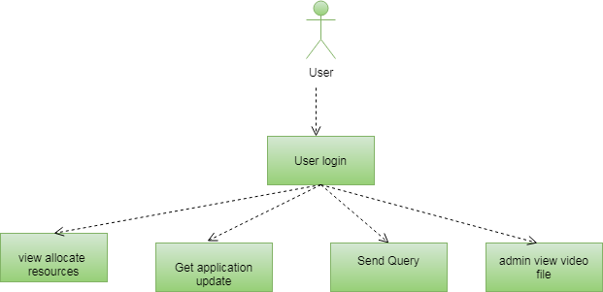
Fig 3.2 .1 user use case diagram
b.Admin
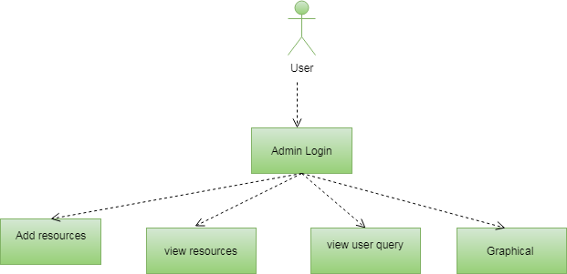
Fig 3.2.2 admin use case diagram

3.3 CLASS DIAGRAM

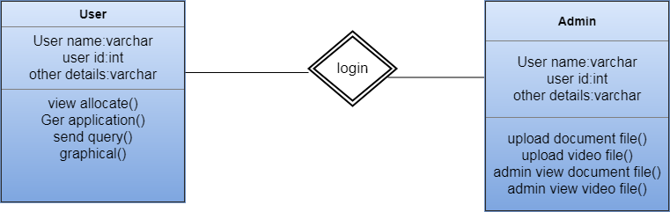
Fig 3.3 class diagram

3.4 SEQUENCE DIAGRAM
a.User
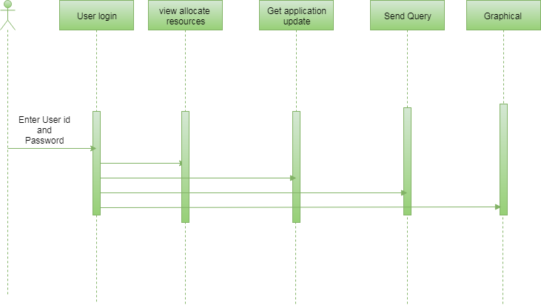
Fig 3.4.1 use sequense diagram

c.Admin

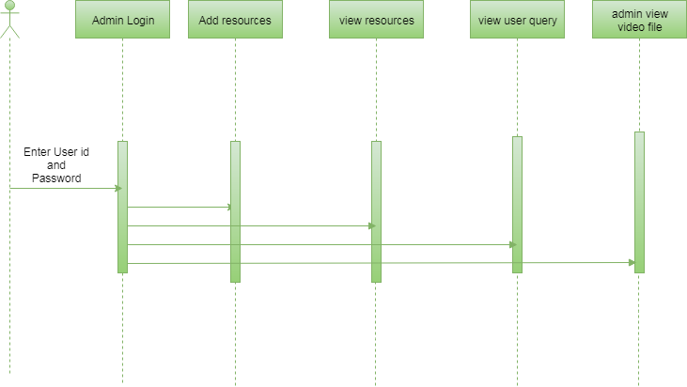
Fig 3.4.2 admin sequence diagram
3.5 ACTIVITY DIAGRAM
a.User
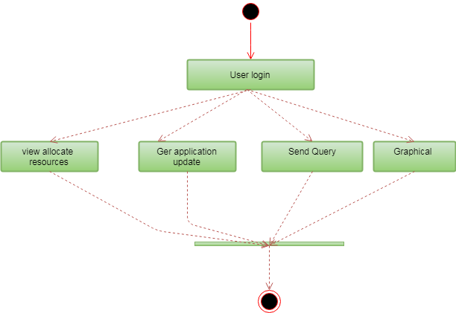
Fig 3.5.1 user activity diagram
b.Admin
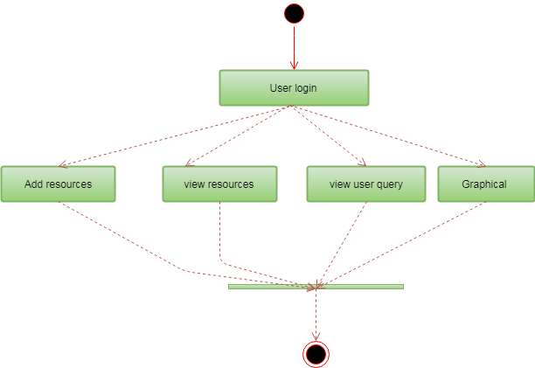
Fig 3.5.2 admin activity diagram
- IMPLEMENTATION
from __future__ import unicode_literals
from django.conf import settings
from django.db import migrations, models
import django.db.models.deletion
class Migration(migrations.Migration):
initial = True
dependencies = [
migrations.swappable_dependency(settings.AUTH_USER_MODEL),
]
operations = [
migrations.CreateModel(
name='Orders',
fields=[
('id', models.AutoField(auto_created=True, primary_key=True, serialize=False, verbose_name='ID')),
('prodname', models.CharField(max_length=200)),
('prodweight', models.IntegerField()),
('prodprice', models.CharField(max_length=200)),
('prodqty', models.IntegerField()),
('category', models.IntegerField(max_length=2)),
('images', models.FileField(upload_to='')),
('location', models.CharField(max_length=200)),
('user', models.ForeignKey(on_delete=django.db.models.deletion.CASCADE, to=settings.AUTH_USER_MODEL)),
],
),
]
from __future__ import unicode_literals
from django.db import migrations, models
import django.db.models.deletion
class Migration(migrations.Migration),
dependencies = [
('serviceprovider', '0003_product_category'),
('consumer', '0001_initial'),
]
operations = [
migrations.RemoveField(
model_name='orders',
name='category',
),
migrations.RemoveField(
model_name='orders',
name='images',
),
migrations.RemoveField(
model_name='orders',
name='prodname',
),
migrations.RemoveField(
model_name='orders',
name='prodprice',
),
migrations.RemoveField(
model_name='orders',
name='prodweight',
),
migrations.AddField(
model_name='orders',
name='prod',
field=models.ForeignKey(default=1, on_delete=django.db.models.deletion.CASCADE, to='serviceprovider.Product'),
preserve_default=False,
),
]
rom __future__ import unicode_literals
from django.conf import settings
from django.db import migrations, models
import django.db.models.deletion
class Migration(migrations.Migration):
dependencies = [
migrations.swappable_dependency(settings.AUTH_USER_MODEL),
('serviceprovider', '0003_product_category'),
('consumer', '0002_auto_20171202_1124'),
]
operations = [
migrations.CreateModel(
name='Ratings',
fields=[
('id', models.AutoField(auto_created=True, primary_key=True, serialize=False, verbose_name='ID')),
('rpcost', models.IntegerField(max_length=200)),
('rpquality', models.IntegerField(max_length=200)),
('rsflexibitilty', models.IntegerField(max_length=200)),
('rstrust', models.IntegerField(max_length=200)),
('rstimedelivery', models.IntegerField(max_length=200)),
('orders', models.ForeignKey(on_delete=django.db.models.deletion.CASCADE, to='consumer.Orders')),
('prod', models.ForeignKey(on_delete=django.db.models.deletion.CASCADE, to='serviceprovider.Product')),
('user', models.ForeignKey(on_delete=django.db.models.deletion.CASCADE, to=settings.AUTH_USER_MODEL)),
],
),
]
from __future__ import unicode_literals
from django.db import migrations, models
class Migration(migrations.Migration):
dependencies = [
('consumer', '0003_ratings'),
]
operations = [
migrations.AddField(
model_name='orders',
name='approval',
field=models.CharField(default='dev', max_length=200),
preserve_default=False,
),
]
from __future__ import unicode_literals
from django.db import migrations
class Migration(migrations.Migration):
dependencies = [
('consumer', '0004_orders_approval'),
]
operations = [
migrations.RemoveField(
model_name='orders',
name='approval',
),
]
from django.contrib import admin
# Register your models here.
from django.apps import AppConfig
class ConsumerConfig(AppConfig):
name = 'consumer'
from django import forms
from .models import Orders,Ratings

class OrderForm(forms.ModelForm):
class Meta:
model = Orders
fields = ('prodqty', 'location',)
class RatingForm(forms.ModelForm):
class Meta:
model = Ratings
fields = ('rpcost','rpquality','rsflexibitilty','rstrust','rstimedelivery',)
from django.db import models
from django.conf import settings
from serviceprovider.models import Product
class Orders(models.Model):
user = models.ForeignKey(settings.AUTH_USER_MODEL)
prod = models.ForeignKey(Product)
prodqty = models.IntegerField()
location = models.CharField(max_length=200)
def __unicode__(self):
return self.name
from serviceprovider.models import Product
def home(request):
book = Product.objects.all()
data={}
data['object_list'] = book
return render(request,'consumer/index.html', data)
def order(request):
book = Orders.objects.filter(user=request.user)
data={}
data['object_list'] = book
return render(request,'consumer/OrderedList.html', data)
def viewprod(request,pk):
book1= get_object_or_404(Product, pk=pk)
form=OrderForm(request.POST or None, request.FILES)
if form.is_valid():
book = form.save(commit=False)
book.prod= Product.objects.get(id=pk)
book.user = request.user
book.save()
return redirect('consumer:home')
else:
form=OrderForm(request.POST or None, request.FILES)
return render(request,'consumer/viewdata.html', {'book':book1,'form':form})
def addrating(request):
book = Orders.objects.filter(user=request.user)
data={}
data['object_list'] = book
return render(request,'consumer/addrating.html', data)

5. SCREENSHOTS
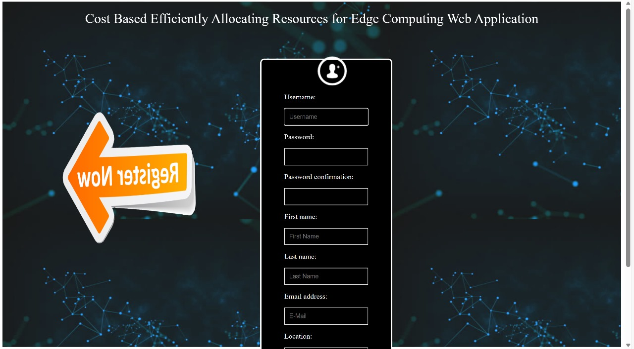
Fig 5.1 user registration
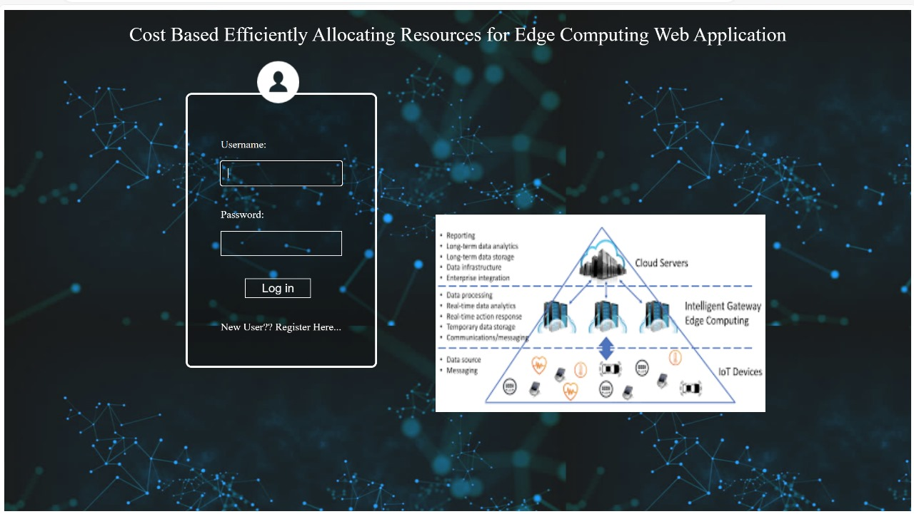
Fig 5.2 user login

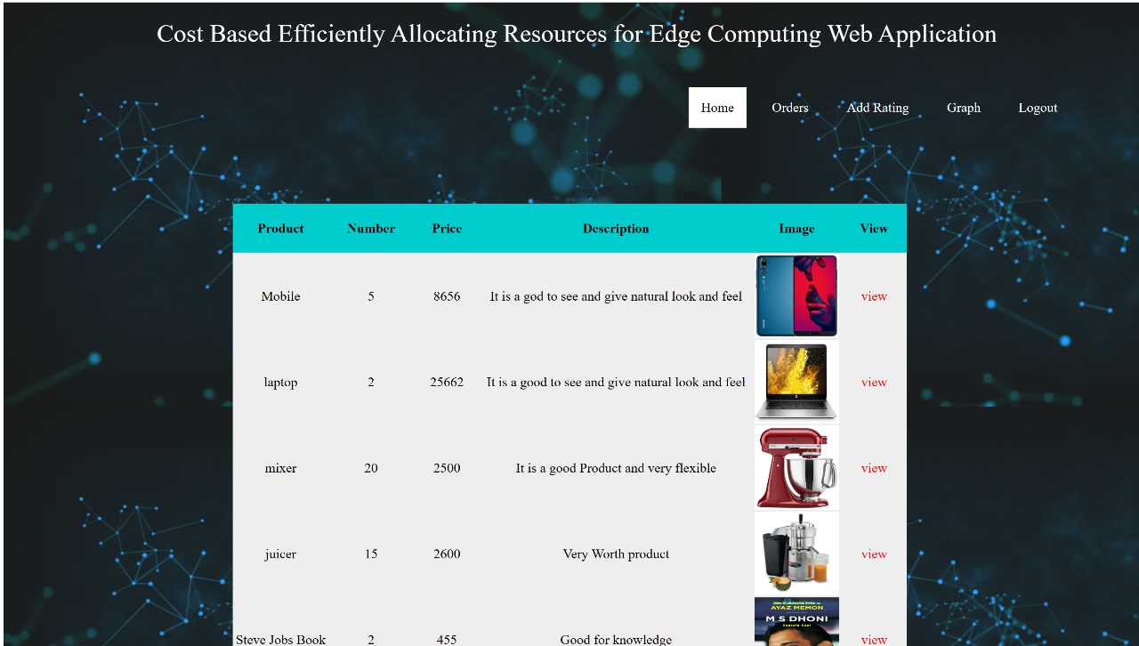
Fig 5.3 view allocate resources

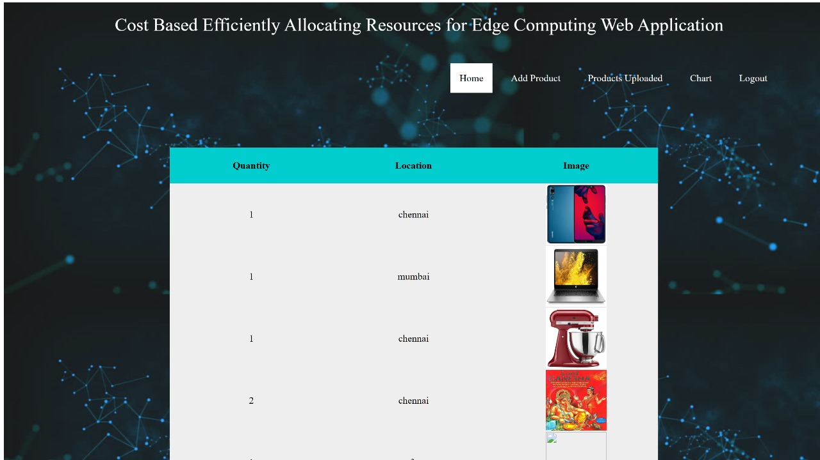
Fig 5.4 view resources

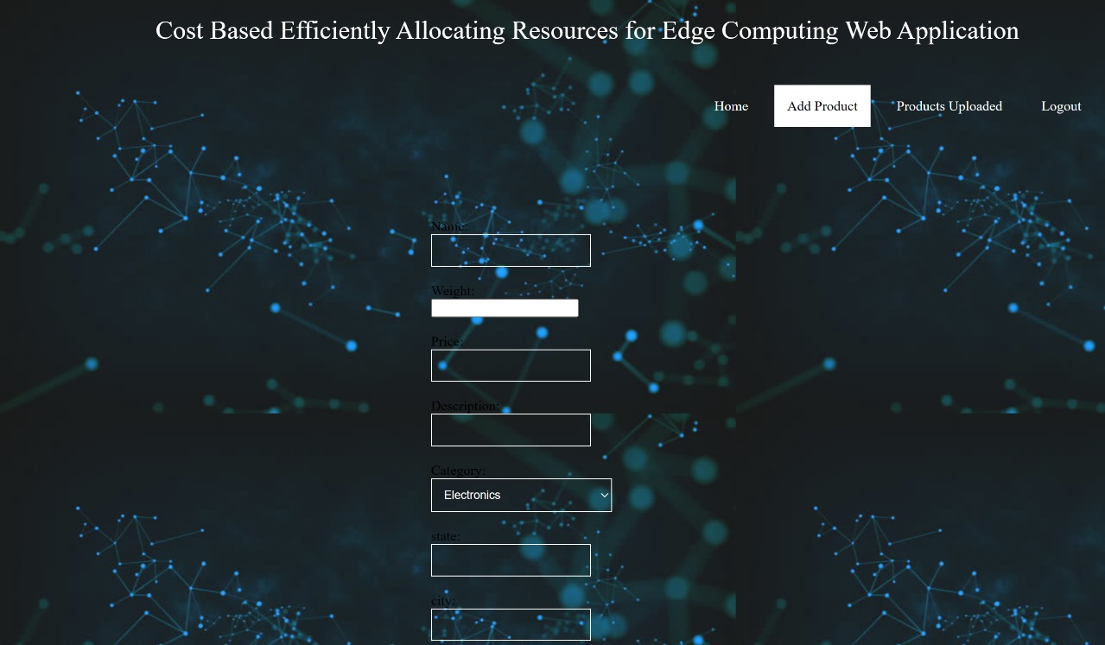
Fig 5.5 add resources

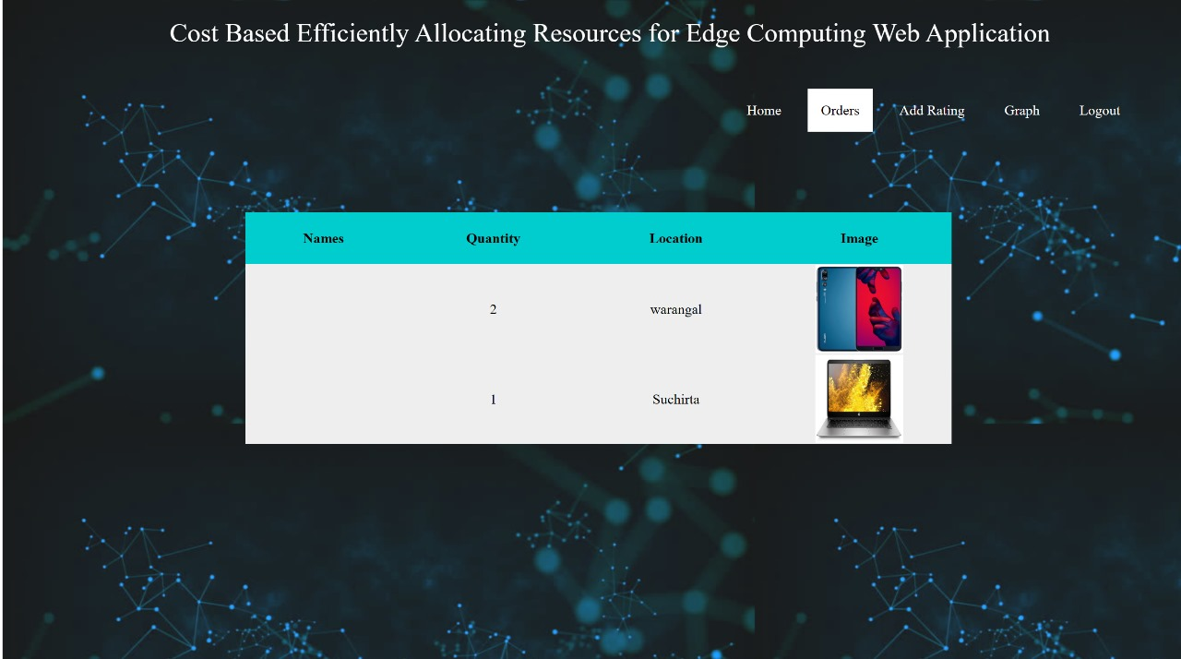
Fig 5.6 orders

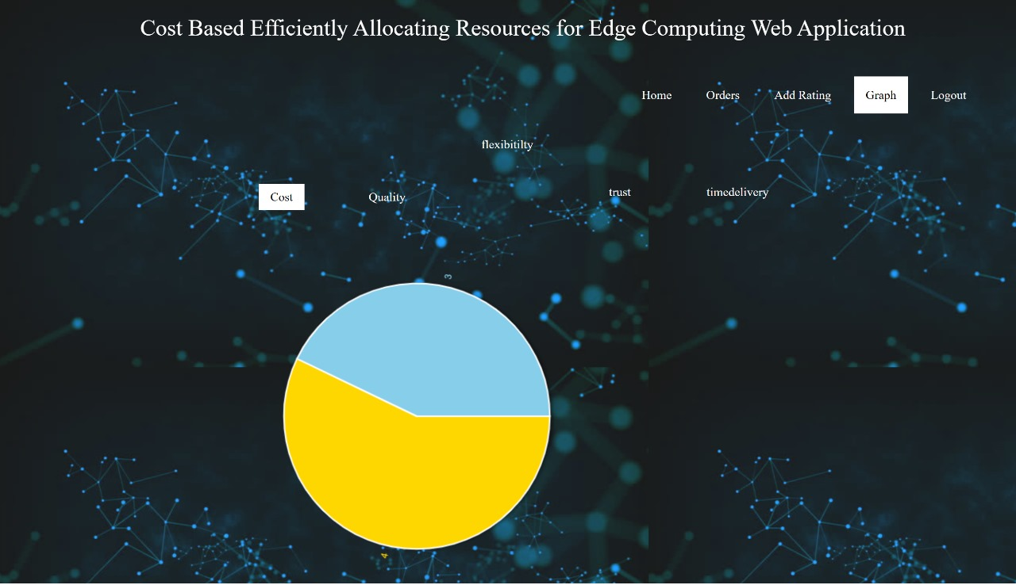
Fig 5.7 graph

6. TESTING
6.1 INTRODUCTION TO TESTING
Testing is a process, which reveals errors in the program. It is the major quality measure employed during software development. During software development. During testing, the program is executed with a set of test cases and the output of the program for the test cases is evaluated to determine if the program is performing as it is expected to perform.
6.2 TYPES OF TESTING
6.2.1 UNIT TESTING
Unit testing is a fundamental aspect of software development that involves testing individual components or units of code in isolation to ensure their correctness and reliability. In unit testing, each component is tested independently to verify that it performs as expected and meets the specified requirements. This process typically involves writing test cases for functions, methods, or classes to validate their behavior under various inputs and conditions. Unit tests are designed to cover different scenarios, including normal operation, boundary cases, and error handling, to uncover potential bugs or defects early in the development cycle. By isolating units of code from their dependencies and executing tests in a controlled environment, unit testing helps identify and fix issues promptly, improves code quality, and enhances overall software maintainability. Automated testing frameworks and tools are often used to streamline the unit testing process, allowing developers to run tests frequently and integrate them seamlessly into their development workflow.

6.2.2 INTEGRATION TESTING
Integration testing is a crucial phase in the software development lifecycle, where individual units or components of the system are combined and tested as a group to ensure that they work together seamlessly. In this phase, the focus shifts from testing individual units in isolation to verifying the interactions and interfaces between different modules, subsystems, or external dependencies. Integration testing aims to uncover any integration issues, such as communication failures, data mismatches, or compatibility problems, that may arise when integrating multiple components. Test cases are designed to simulate various integration scenarios and validate the flow of data and control between interconnected units. By detecting and addressing integration issues early in the development process, integration testing helps ensure the overall functionality, reliability, and interoperability of the system, ultimately reducing the risk of critical failures in production environments. Automated testing tools and techniques are often employed to streamline integration testing and facilitate continuous integration practices, enabling frequent and efficient testing of integrated components throughout the development cycle.
6.2.3 FUNCTIONAL TESTING
窗体底端
Functional testing is a critical aspect of software testing where the system's functionalities are tested against specified requirements to ensure that it behaves as expected from an end-user perspective. This type of testing validates the system's features, functionalities, and user interactions, focusing on verifying that the software meets the intended business objectives and user needs. Functional tests are designed based on functional requirements and use cases, covering various scenarios, inputs, and outputs to validate the system's behavior under different conditions. Test cases may include positive and negative scenarios, boundary cases, and error handling to ensure comprehensive coverage of all possible use cases. Functional testing is typically performed manually or with the assistance of automated testing tools, evaluating both the visible aspects of the software (such as user interfaces) and the underlying functionalities (such as data processing and calculations). By rigorously testing the system's functionalities, functional testing helps ensure the software's reliability, usability, and compliance with business requirements, ultimately delivering a high-quality product to end-users.

6.3 TEST CASES
6.3.1 CLASSIFICATION
In order to make sure that the system does not have errors, the different levels of testing strategies that are applied at differing phases of software development are:
Unit Testing:
Unit Testing is done on individual modules as they are completed and become executable. It is confined only to the designer's requirements.
Each module can be tested using the following two Strategies:
Black Box Testing:
In this strategy some test cases are generated as input conditions that fully execute all functional requirements for the program. This testing has been uses to find errors in the following categories:
- Incorrect or missing functions
- Interface errors
- Errors in data structure or external database access
- Performance errors
- Initialization and termination errors.
In this testing only the output is checked for correctness. The logical flow of the data is not checked.
White Box testing:
In this the test cases are generated on the logic of each module by drawing flow graphs of that module and logical decisions are tested on all the cases. It has been uses to generate the test cases in the following cases:
- Guarantee that all independent paths have been Executed.
- Execute all logical decisions on their true and false Sides.
- Execute all loops at their boundaries and within their operational bounds
- Execute internal data structures to ensure their validity.

Integrating Testing :
Integration testing ensures that software and subsystems work together a whole. It tests the interface of all the modules to make sure that the modules behave properly when integrated together.
System Testing :
Involves in-house testing of the entire system before delivery to the user. It's aim is to satisfy the user the system meets all requirements of the client's specifications.
Acceptance Testing :
It is a pre-delivery testing in which entire system is tested at client's site on real world data to find errors.

Test Approach :
Testing can be done in two ways:
- Bottom up approach
- Top down approach
Bottom up Approach:
Testing can be performed starting from smallest and lowest level modules and proceeding one at a time. For each module in bottom up testing a short program executes the module and provides the needed data so that the module is asked to perform the way it will when embedded with in the larger system. When bottom level modules are tested attention turns to those on the next level that use the lower level ones they are tested individually and then linked with the previously examined lower level modules.
Top down approach:
This type of testing starts from upper level modules. Since the detailed activities usually performed in the lower level routines are not provided stubs are written. A stub is a module shell called by upper level module and that when reached properly will return a message to the calling module indicating that proper interaction occurred. No attempt is made to verify the correctness of the lower level module.

7. CONCLUSION & FUTURE SCOPE
7.1 PROJECT CONCLUSION
In this work, we consider the resource allocation for an EC system which consists geographically distributed heterogeneous ENs with different configurations and a collection of services with different desires and buying power. Our main contribution is to suggest the famous concept of General Equilibrium in Economics as an effective solution for the underlying EC resource allocation problem. The proposed solution produces an ME that not only Pareto-efficient but also possesses many attractive fairness properties. The potential of this approach are well beyond EC applications. For example, it can be used to share storage space in edge caches to different service providers. We can also utilize the proposed framework to share resources (e.g., communication, wireless channels) to different users or groups of users (instead of services and service providers). Furthermore, the proposed model can extend to the multi-resource scenario where each buyer needs a combination of different resource types (e.g., storage, bandwidth, and compute) to run its service. We will formally report these cases (e.g., network slicing, NFV chaining applications) in our future work.
7.2 FUTURE SCOPE
The future scope of the e-commerce platform leveraging edge computing is promising and expansive. Moving forward, advancements in edge computing technologies will enable the platform to offer enhanced capabilities and functionalities. One area of future development lies in advanced personalization features, where the platform can leverage real-time data analysis at the edge to deliver highly personalized shopping experiences for users. Additionally, further integration of Internet of Things (IoT) devices with the platform opens up opportunities for innovative applications, such as smart product recommendations based on real-time sensor data. Moreover, the platform can explore edge analytics to gain valuable insights into customer behavior, market trends, and inventory management, enabling businesses to make data-driven decisions and optimize their operations. As edge computing continues to evolve, the e-commerce platform can expand its scope to include more sophisticated features, improved performance, and seamless integration with emerging technologies, positioning itself as a leader in the ever-evolving landscape of online retail.

8. REFERENCES
8.1 REFERENCES
1. M. Chiang and T.Zhang, “Fog and IoT: an overview of research opportunities,” IEEE Internet Things J., vol. 3, no. 6, pp. 854–864, Dec. 2016.
2. M. Satyanarayanan, “The emergence of edge computing,” Computer, vol. 50, no. 1, pp. 30–39, Jan. 2017.
3. W. Shi, J. Cao, Q. Zhang, Y. Li, and L. Xu, “Edge computing: vision and challenges,” IEEE Internet Things J., vol. 3, no. 5, pp. 637–646, Oct. 2016.
4. L. Gu, D. Zeng, S. Guo, A. Barnawi, and Y. Xiang, “Cost efficient resource management in fog computing supported medical cyberphysical system,” IEEE Trans. Emerg. Topics Comput., vol. 5, no. 1, pp. 108-119, Jan.-Mar. 2017.
5. A. Mukherjee, D. De, and D.G. Roy, “A power and latency aware cloudlet selection strategy for multi-cloudlet environment,” IEEE Trans. Cloud Comput. , to appear.
6. R. Deng, R. Lu, C. Lai, T. H. Luan, and H. Liang, “Optimal workload allocation in fog-cloud computing toward balanced delay and power consumption,” IEEE Internet Things J., vol. 3, no. 6, pp. 1171–1181, Dec. 2016.
7. D.Ardagna, M.Ciavotta,and M.Passacantando, “Generalized Nash equilibria for the service provisioning problem in multicloud systems,” IEEE Trans. Serv. Comput., vol. 10, no. 3, pp. 381– 395, May-Jun. 2017.

8.2 GITHUB LINK

